Perry Art Park Committee
(The Perry Art Park Committee consists of Mornings, Beyt, Robinson, Flowers, McVey, Winslow, Adams, Lindley, Jameson, Cody, Hensley)
.
The Rauch Family
Pool of anonymous donations - general

The Winslow/Smaha Family
The Box Family
The Bosarge / McVey Family
The Braecklein Family
The Miller Family
The Lynch/Beyt Family

The Alex and Zoe Beyt/Lynch Lemonade Stand (250!!)
The Stanford Family
The Morning Family
The Storey and Sydney Flowers Lemonade Stand ($327.90!!)
Pool of Donations from Beverly Hood Neighborhood
Pool of Donations from the Ridge Oak Median Area
The Oatman Family
The Latson Family
The Goff Family
The Roberts Family
The Schmidt Family
The Ditson Family
The McCants Family
The Sargent Family
The Casey Family
The Herfurth Family

HIGHLAND PARK ELEMENTARY PTA
HIGHLAND PARK WEST BALCONES AREA NEIGHBORHOOD ASSOCIATION
In-kind Services from Paradigm Contracting, LLC
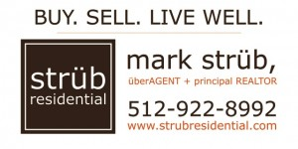

Crenshaw Athletic Club
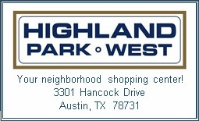
Charles McVey PhD, Psychologist




